CHAPTER III
RESULTS AND DISCUSSION
Findings
This chapter presents the findings of the study based on the identified problems and objectives. It includes the analysis of the existing procurement processes and record-keeping practices, the design and development of the proposed SmartProcure system, and the evaluation of the system.
Problem 1. What are the current procurement processes and record-keeping practices at ASIST, and what difficulties are encountered in terms of:
a. Processing
b. Monitoring
c. Documenting
d. Retrieving
Data for this objective were gathered through a structured interview questionnaire administered to a procurement staff member directly involved in purchase request preparation, approval, procurement monitoring, document handling, and record-keeping. Although the study intended to employ total enumeration of all procurement staff of the institution, only one respondent was available at the time of data gathering. No statistical treatment was applied; consistent with the study's data analysis procedure for this objective, the responses were examined and organized qualitatively to identify the existing procurement processes, record-keeping practices, and the difficulties encountered in terms of processing, monitoring, documenting, and retrieving procurement records.
Question / Indicator | Response
a. Processing
Systems/tools used for financial or administrative transactions | Manual (paper-based); Excel/Spreadsheets
Systems/tools used for budget preparation, allocation, and monitoring | Manual
Processes still done manually | Document preparation; verification and validation; approvals; tracking and monitoring; reporting
Types of documents handled | Purchase requests; vouchers/disbursement vouchers; invoices; receipts/collections
How documents are received from other offices | Physically delivered
How documents are forwarded to the next office | Physical hand-carry
How documents are verified and validated | Manual checking; cross-checking with records; approval/signature-based
Length of the verification and validation process | More than 5 days
Common problems in daily financial/administrative transactions | Delays; data inconsistency; duplicate records; manual errors; difficulty tracking transaction status
b. Monitoring
How transaction status is monitored | Manual follow-up; paper logs
Are transaction statuses (pending, approved, completed) traceable? | Yes
Is it easy to identify who handled/approved a transaction? | Yes
Can the complete history of a transaction be traced when needed? | Yes
Time to verify a transaction's status | Few minutes
Time to generate a standard report | 1 day
Frequency of coordination with other offices | Daily
Frequency of following up on pending transactions | Daily
Challenges in inter-office coordination | Delayed responses; missing or incomplete documents; no clear transaction status; repeated follow-ups
c. Documenting
How financial/budget-related documents are stored and retrieved | Paper-based filing; Excel/spreadsheets
How documents/information are shared between offices | Paper-based; email
Standard document format/template used for inter-office communication? | Yes
Shared log or tracker for inter-office transactions | Physical logbook
Tools used for inter-office communication | Phone calls; email; messaging apps; face-to-face
Problems encountered in budget management | Records hard to locate; time-consuming record-keeping; errors or miscalculations; delayed budget reports; data inconsistency or duplication; difficulty tracking remaining balances; poor coordination with other offices; risk of lost or damaged documents
Frequency of budget documents needing reprocessing due to errors | Sometimes
Does the current system affect decision-making due to delayed/incomplete information? | Yes
d. Retrieving
What happens after documents are approved | Forwarded to another office; filed/stored; used for payment/release
Problems encountered in record management | Hard-to-locate records; time-consuming retrieval; errors and inconsistencies; delayed reports; risk of data loss
Perceived security of records in the current system | Very secure
Table 1. Current Procurement Processes, Record-Keeping Practices, and Difficulties Encountered
(Based on Interview Response)
The table presents the current procurement processes and record-keeping practices of the office, along with the difficulties encountered in terms of processing, monitoring, documenting, and retrieving procurement records, as reported by the respondent.
a. Processing
In terms of processing, the respondent reported that procurement and budget-related transactions are still carried out mainly through manual, paper-based methods, occasionally supplemented by Excel spreadsheets, while budget preparation, allocation, and monitoring remain entirely manual. Document preparation, verification and validation, approvals, tracking and monitoring, and reporting were all identified as processes still performed manually. The office regularly handles purchase requests, vouchers/disbursement vouchers, invoices, and receipts/collections, all of which are physically delivered and hand-carried between offices. Verification and validation rely on manual checking, cross-checking with records, and approval or signature-based procedures, and this process was reported to take more than five days to complete. Delays, data inconsistency, duplicate records, manual errors, and difficulty tracking transaction status were also identified as recurring problems in daily financial and administrative transactions.
These findings indicate that procurement processing in the office remains heavily dependent on manual, paper-based methods with minimal digital support, resulting in a lengthy and error-prone verification process. The reliance on physical document handling and manual cross-checking helps explain why verification alone can take more than five days, and why delays, inconsistencies, and duplication continue to affect day-to-day transactions.
b. Monitoring
For monitoring, the respondent indicated that transaction status is tracked through manual follow-up and paper logs rather than any automated or system-generated method. Despite this, she reported that transaction statuses are traceable, that it is easy to identify who handled or approved a transaction, and that the complete history of a transaction can be traced when needed, with status verification typically taking only a few minutes. Generating a standard report, however, was reported to take about a full day. Coordination with other offices occurs daily, and the respondent also needs to follow up on pending transactions daily, citing delayed responses, missing or incomplete documents, unclear transaction status, and repeated follow-ups as recurring inter-office coordination challenges.
While the respondent's familiarity with her own paper-based logs allows her to trace individual transactions relatively quickly, the daily need for follow-up and the day-long turnaround for generating reports suggest that monitoring remains time-consuming and dependent on manual effort rather than a centralized system that could make transaction status and reports readily available to all concerned offices.
c. Documenting
In terms of documenting and record-keeping, the respondent reported that financial and budget-related documents are stored using paper-based filing combined with Excel spreadsheets, and that documents are shared with other offices through paper-based means and email. A standard document format or template is used for inter-office communication, and a physical logbook serves as the shared tracker for inter-office transactions, supplemented by phone calls, email, messaging apps, and face-to-face communication. In terms of budget management specifically, the respondent identified nearly every listed difficulty as a recurring problem, including records that are hard to locate, time-consuming record-keeping, errors or miscalculations, delayed budget reports, data inconsistency or duplication, difficulty tracking remaining balances, poor coordination with other offices, and risk of lost or damaged documents. Budget documents were reported to require reprocessing due to errors “sometimes,” and the respondent confirmed that delayed or incomplete information does affect decision-making.
These results suggest that although the office has established manual procedures and tools, such as logbooks, spreadsheets, and standard formats, for documenting transactions, its continued reliance on paper-based and only partially digitized methods leaves budget-related documentation especially vulnerable to errors, inconsistency, and delay, which in turn directly affects the timeliness and quality of decision-making.
d. Retrieving
On record retrieval, the respondent identified hard-to-locate records, time-consuming retrieval, errors and inconsistencies, delayed reports, and risk of data loss as problems encountered in record management. After documents are approved, they are typically forwarded to another office, filed or stored, and used for payment or release. Notably, despite these retrieval-related difficulties, the respondent rated the security of records under the current system as “very secure.”
This apparent contrast, records being considered secure yet difficult and time-consuming to retrieve, reflects a common characteristic of paper-based filing systems: physical documents may be safely kept, but the lack of centralized indexing and searchability makes locating and retrieving them inefficient, contributing to delayed reports and recurring data-retrieval problems.
Overall, the findings reveal that procurement processing, monitoring, documenting, and retrieving in the office remain heavily dependent on manual, paper-based methods, with only minimal use of digital tools such as spreadsheets. While certain aspects, such as transaction traceability and the perceived security of records, appear to be reasonably managed under the current system, difficulties such as delays, data inconsistency, manual errors, and time-consuming retrieval remain evident across nearly all areas of procurement and record-keeping. These findings, though drawn from a single respondent and thus limited in generalizability, highlight the need for a centralized, automated, and digital procurement system such as SmartProcure to reduce reliance on manual processes, minimize errors and delays, and improve the timeliness and accessibility of procurement records.
Problem 2. How can a practical digitalized procurement system, suited to the needs and resources of ASIST, be designed and developed to improve the efficiency of procurement processes and provide centralized record-keeping?
Guided directly by the difficulties identified under Problem 1 (manual, paper-based processing; time-consuming monitoring; error-prone documenting; and slow, unreliable retrieval), the researchers designed and developed SmartProcure following the Input-Process-Output framework and the Agile development model described in Chapter II. The system was built as a web-based application using Python with the Flask framework for backend and server-side logic, MySQL as the relational database for storing employee, account, and procurement records, and HTML with Bootstrap for the user interface, consistent with the software tools identified in the study's methodology. Access to the system is restricted to Abra State Institute of Sciences and Technology personnel who are verified, through their Employee ID, to belong to the Procurement Office, in line with the scope stated in Chapter I. The subsections that follow present each major module of the developed system, the specific procurement or record-keeping difficulty it addresses, and the corresponding screen or output of the system. Consistent with the delimitation stated in Chapter I, the system concentrates on the digitization, archiving, retrieval, and reporting of procurement records. It is built from open-source components (Python, Flask, MySQL, and Bootstrap) that run in a standard web browser and uses the device's own camera rather than dedicated scanning equipment, which suits the resources of the institution. Purchase request submission, approval routing, and transaction status tracking are not part of this version. The modules below therefore address the documenting, retrieving, and reporting difficulties directly and the monitoring difficulties only in part, while the processing delays that arise from inter-office routing remain for future development.
a. Account Registration and Secure Login
New users register using their Employee ID, which the system checks against institutional employee records to confirm the applicant is Procurement Office personnel before an account can be created. The system enforces a username of 8 to 10 alphanumeric characters and a password of 8 to 12 characters containing an uppercase letter, a lowercase letter, a number, and a special character, and checks in real time whether a chosen username is already taken. Passwords are never stored as plain text; they are hashed before being saved to the database. To log in, a registered user supplies their username and password, after which SmartProcure sends a six-digit, time-limited verification code to the user's registered email address as a second authentication factor; the account is only granted access to the dashboard once this code is correctly entered. Repeated failed login or verification attempts are automatically throttled, and an active session automatically expires after 30 minutes of inactivity. Together, these measures directly respond to the security and access-control expectations discussed in Chapter I in relation to protecting procurement records from unauthorized access.
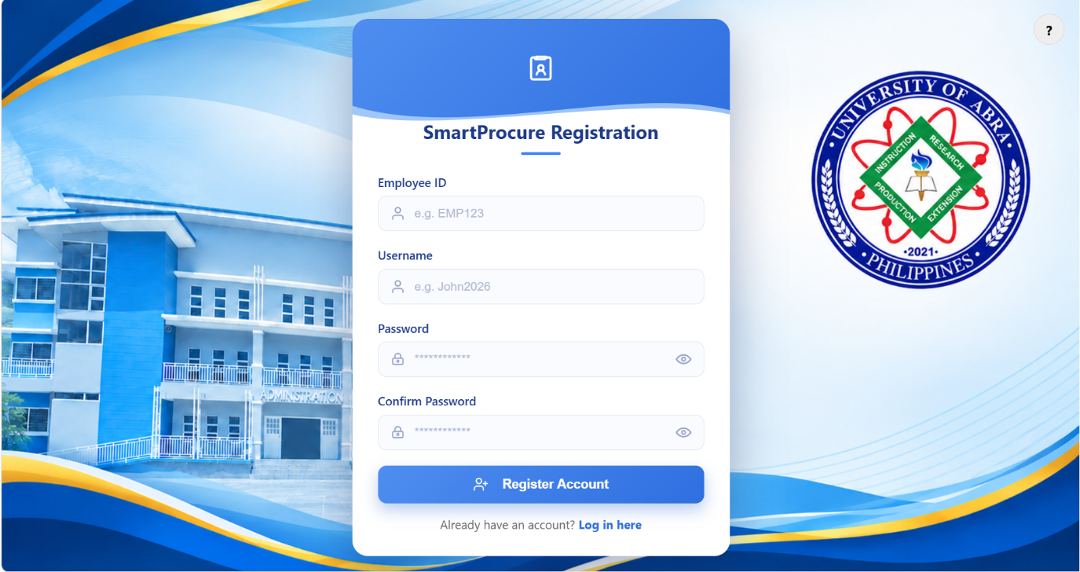
Plate 1. Account Registration Page
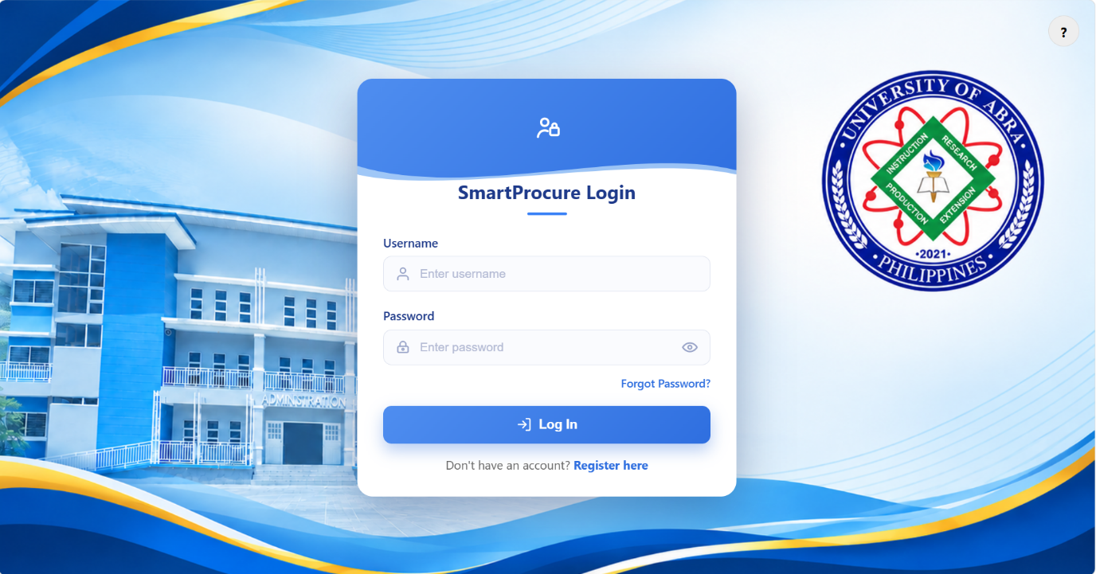Plate 2. Login Page
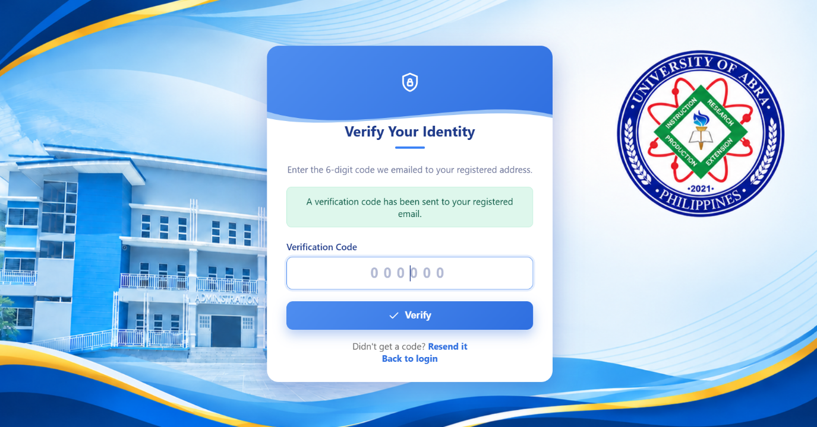Plate 3. Multi-Factor Authentication (Email Verification) Page

b. Password Recovery
Users who forget their password may request a reset by entering their Employee ID. Once the system confirms the Employee ID belongs to a registered Procurement Office account, it emails a secure reset link that expires after 15 minutes and can only be used once. The user then sets a new password, which must satisfy the same complexity requirements enforced at registration. This module reduces the office's dependence on manual, in-person account recovery and keeps password resets auditable.
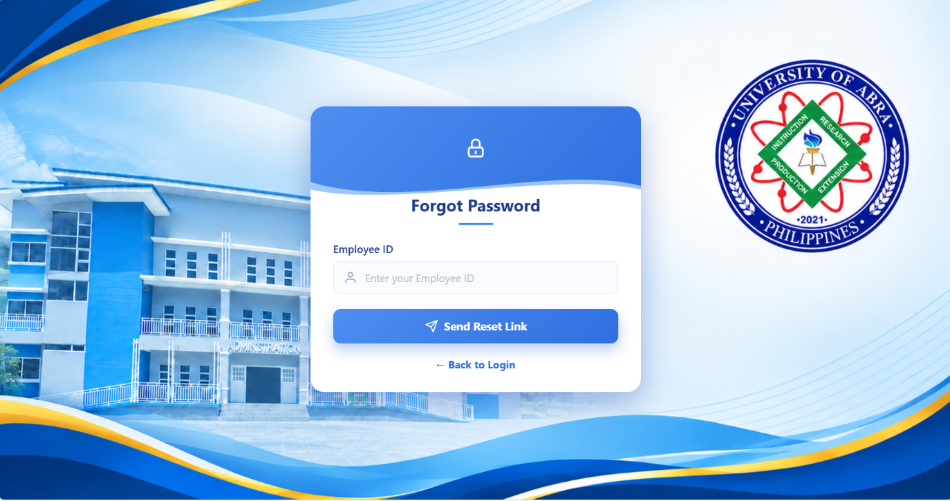Plate 4. Forgot Password Page
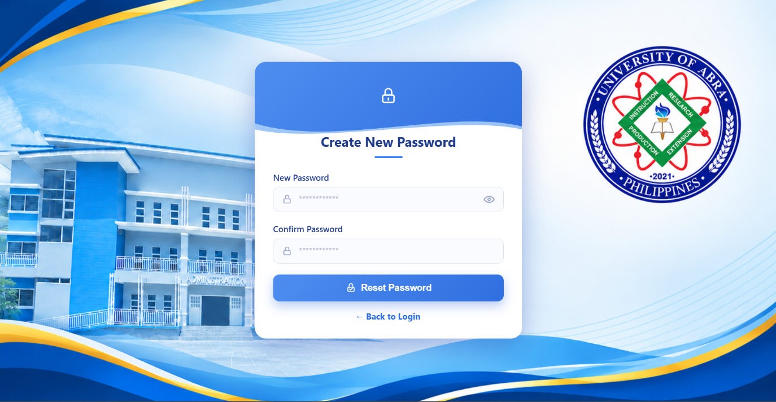Plate 5. Reset Password Page
c. Archive Dashboard
Upon logging in, the user is brought to an Archive Dashboard that displays, at a glance, the total number of Purchase Orders (PO) and Purchase Requests (PR) currently archived in the system, along with a list of the most recently added documents and who uploaded them. This addresses part of the visibility and reporting difficulties identified under Problem 1, where the respondent reported that transaction status was tracked only through manual follow-up and paper logs, and that producing a standard report could take about a full day; the dashboard instead makes archive-level information (the number of archived PRs and POs and the latest uploads) available instantly, without any manual tallying, although it does not track the approval status of individual transactions.
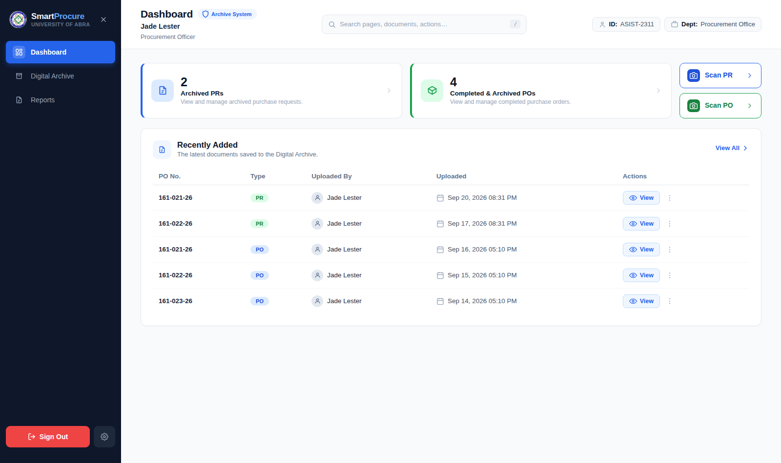
Plate 6. Archive Dashboard
d. Document Scanning and Digitization (PO and PR Scanner)
The scanner module is the system's direct response to the heavily manual, paper-based processing and documenting practices identified under Problem 1. SmartProcure provides two dedicated scanners, one for Approved Purchase Orders and one for Purchase Requests. The user positions the physical document under the device's camera, and the system automatically detects the document's edges and corrects its perspective, presenting an adjustable crop outline that the user may fine-tune before confirming; several pages can be captured in sequence to build a single multi-page record. To reduce manual encoding, the system reads text from the captured page and automatically fills in the PO or PR reference number field, which the user can review and correct before saving. When the user saves the record, the captured pages are compiled into a single PDF, and the system verifies that the uploaded file is a genuine PDF and checks its reference number against those already archived to prevent duplicate entries. Once a document is successfully archived, the system automatically generates a QR code for its reference number, which can be printed and attached to the physical document for quick look-up.
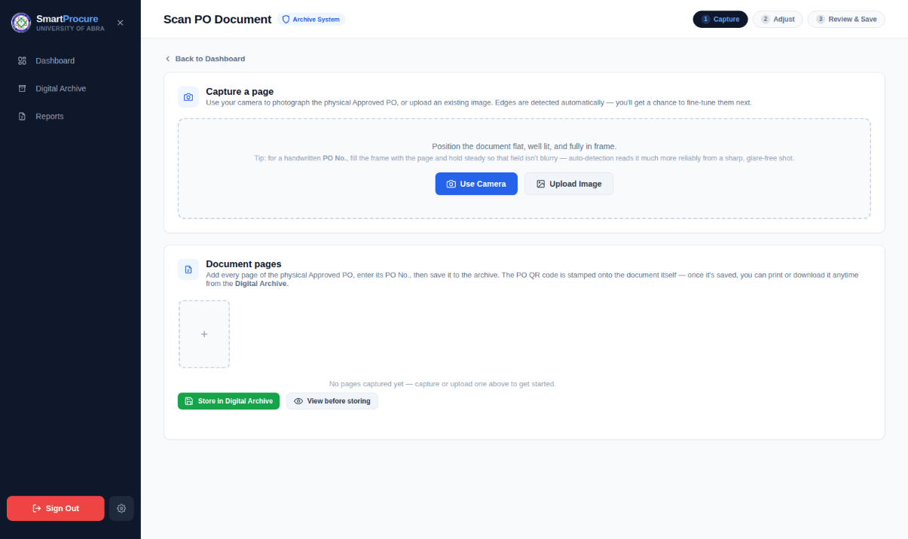
Plate 7. PO Scanner - Document Capture
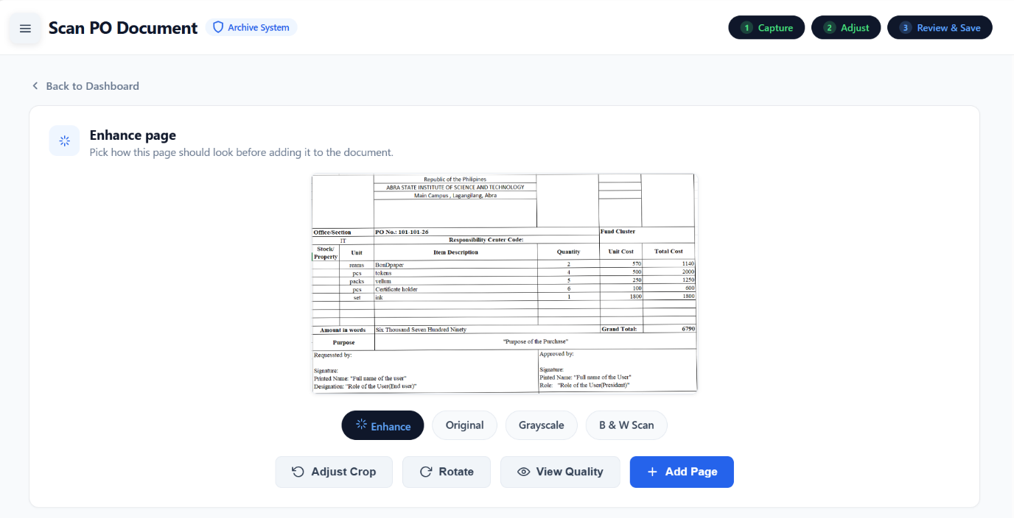
Plate 8. PO Scanner - Crop and Perspective Adjustment
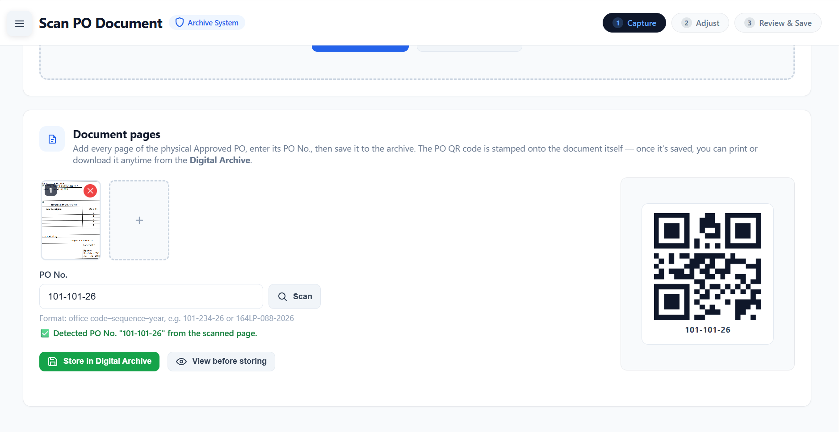
Plate 9. PO Scanner - Reference Number Auto-fill and Generated QR Code

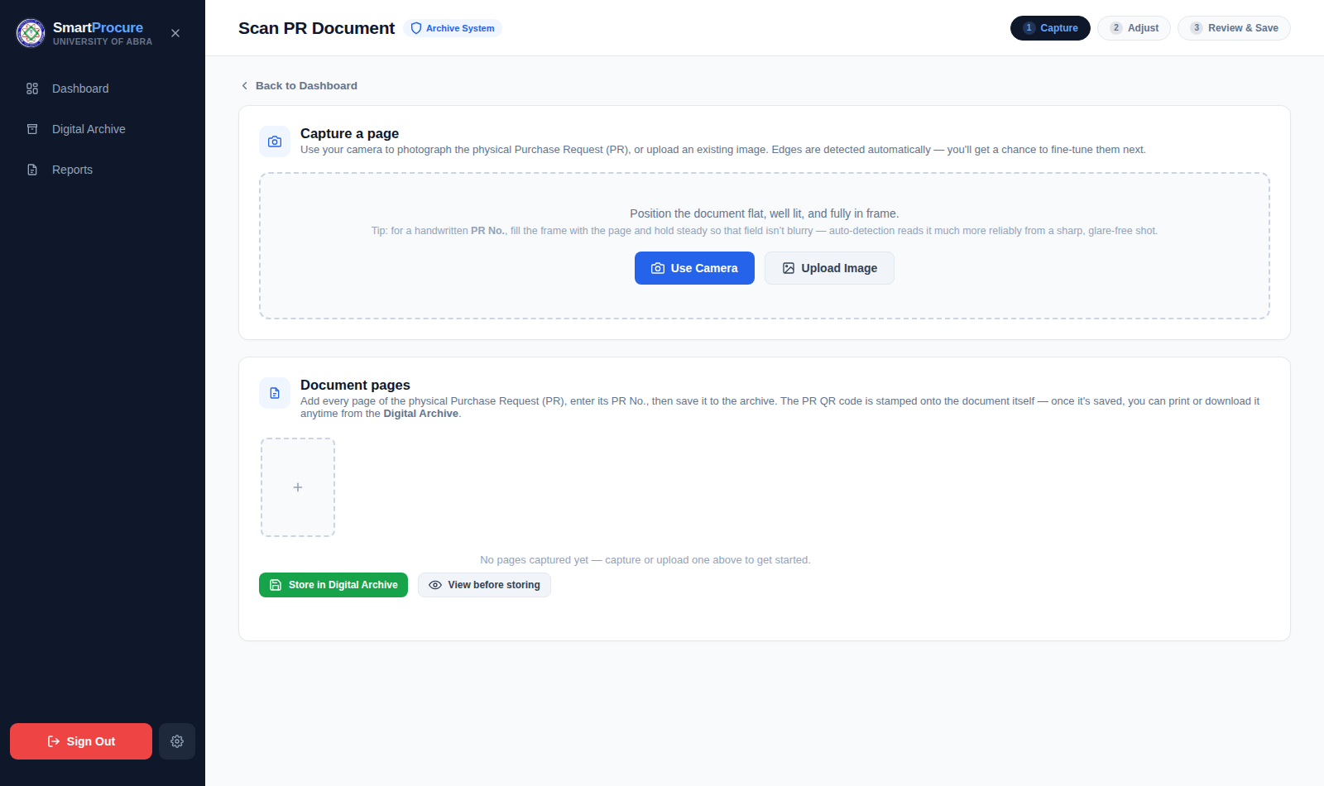
Plate 10. PR Scanner Page
e. Digital Archive and PR-PO Verification
All archived PR and PO records are kept in a centralized, searchable Digital Archive, where each entry shows its reference number, document type, uploader, upload date, and page count. From this page, an authorized user may view, download, or print a document, or delete a record that was archived in error. A verification feature allows a user to enter a reference number and instantly check whether a matching PR and PO have both been archived under it, which supports cross-checking between the two related documents. This module directly addresses the retrieving and documenting difficulties identified under Problem 1, where records were reported as hard to locate and time-consuming to retrieve despite being physically "secure."
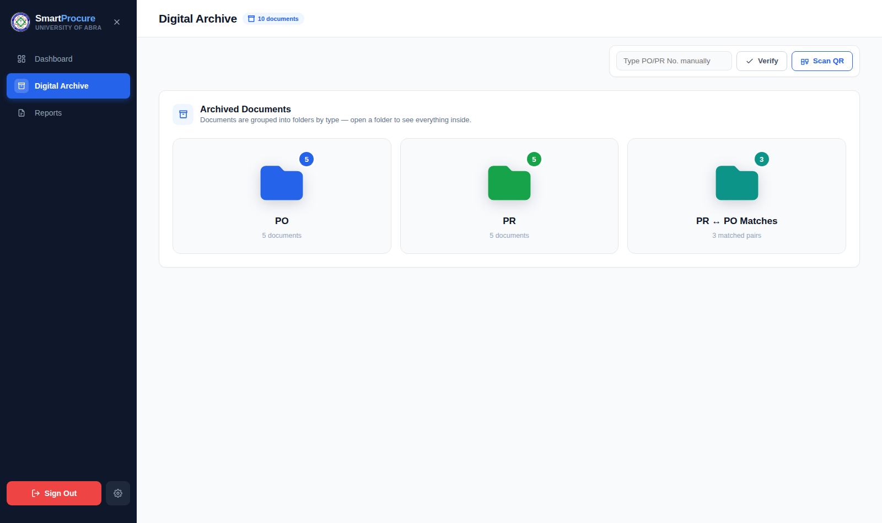Plate 11. Digital Archive Page
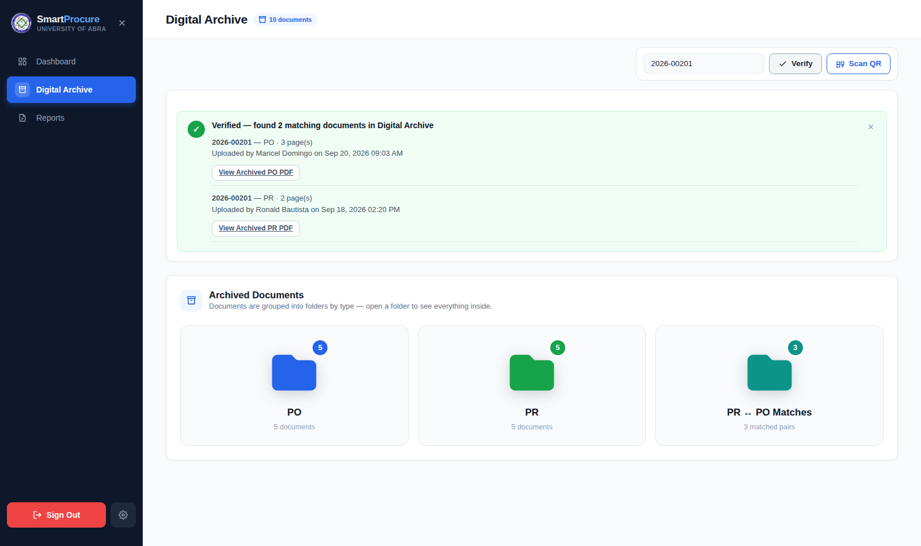Plate 12. PR-PO Verification / Matching Result
f. Reports
The Reports module automatically generates a monthly summary of the number of PR and PO documents archived for a selected year, which can be viewed on screen or downloaded as a CSV file. This gives the Procurement Office a way to produce monthly and annual procurement figures on demand, replacing the manual, day-long report generation described under Problem 1.
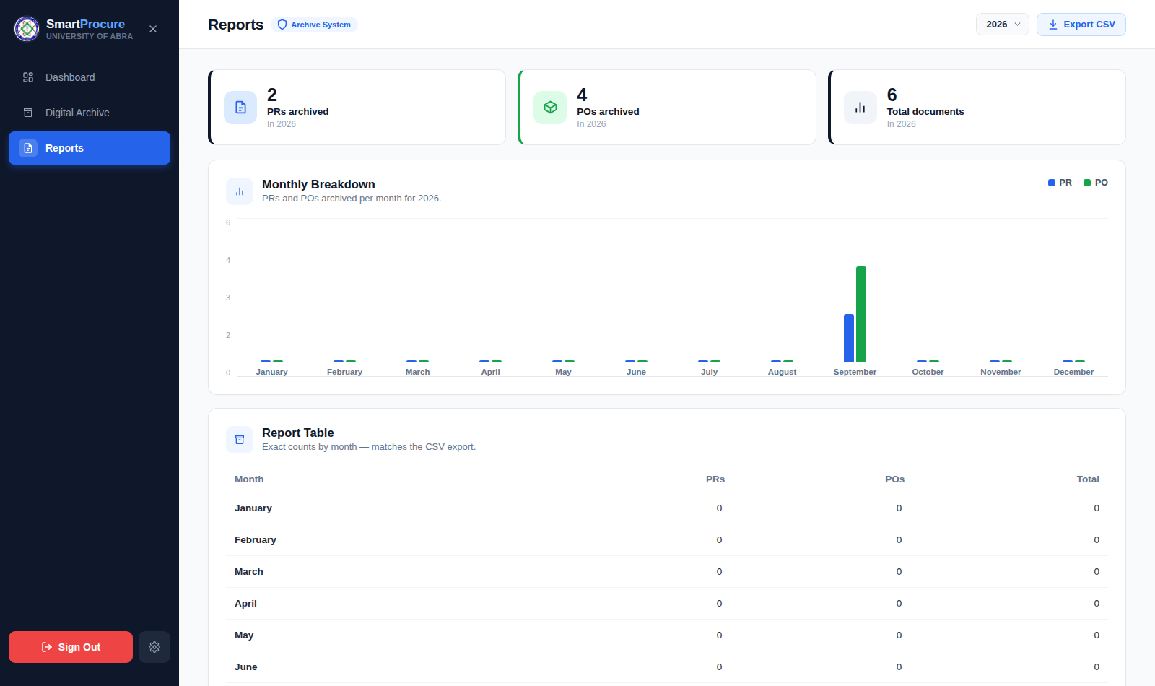Plate 13. Reports Page
g. User Activity Log
Every significant action performed by a user, including logging in and out, registering an account, archiving or deleting a document, viewing, downloading, or printing a record, and changing a password, is automatically recorded together with the acting employee, the date and time, and the device or browser used. The log can be filtered by category, is paginated for ease of review, and can be exported as a CSV file. This module supports the transparency and accountability expectations discussed in Chapter I in connection with RA 9184 and COA documentation requirements, giving the office a verifiable trail of who did what and when.
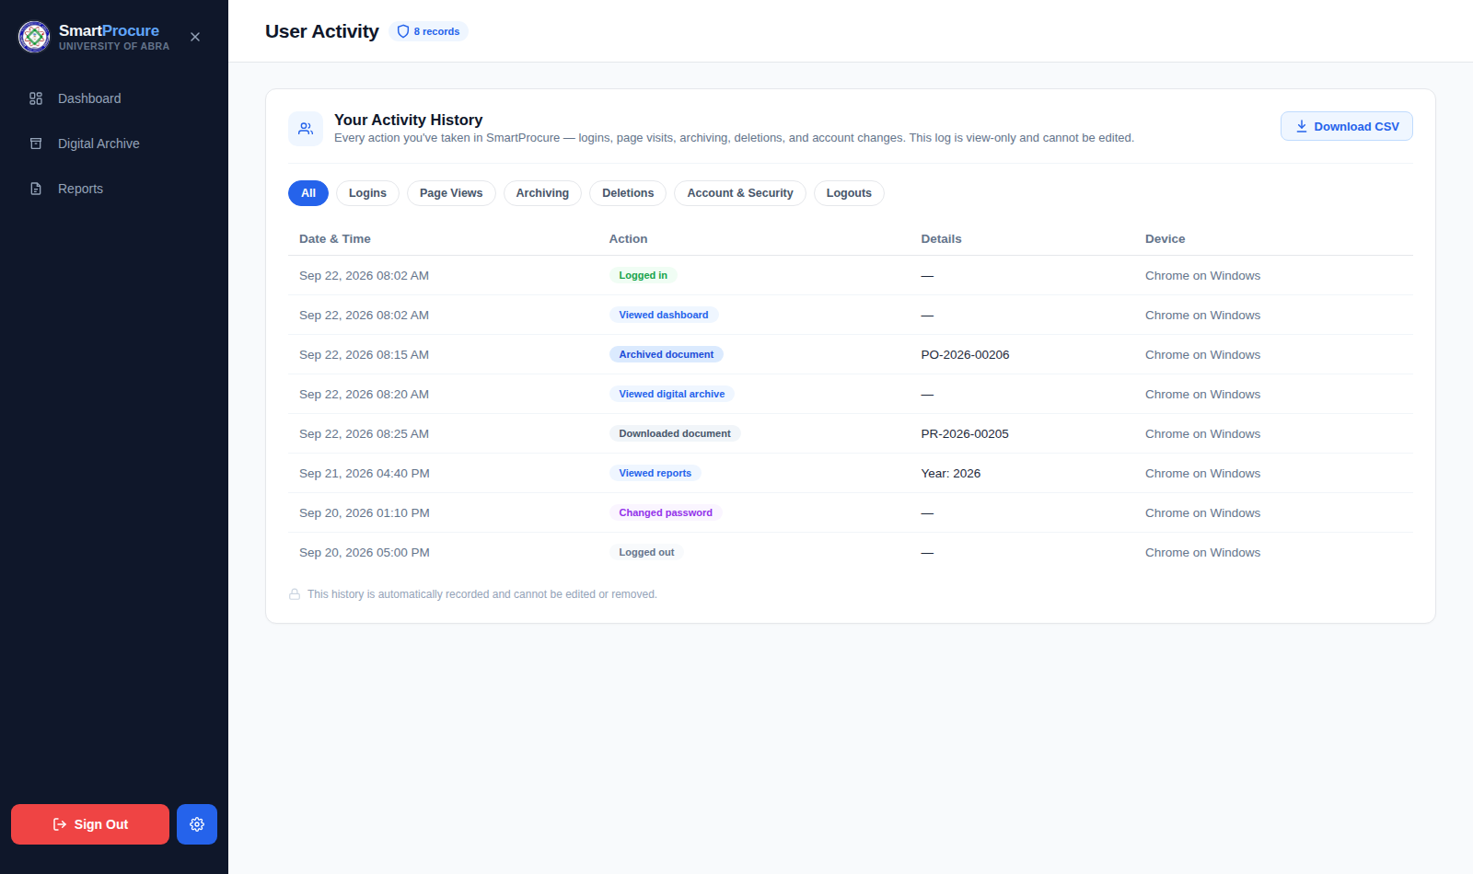plate 14. User Activity Log Page
h. Profile Management
Registered users may update their contact email address and change their password from their profile page. A password change requires the user to correctly enter their current password, and the new password must meet the same complexity requirements enforced at registration and must differ from the current one.
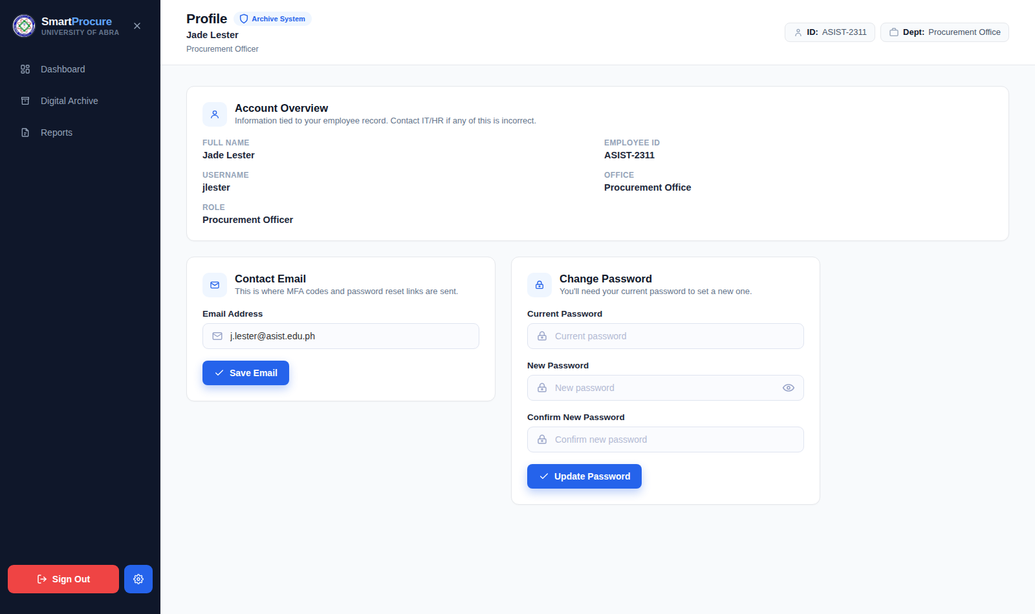Plate 15. Profile Page
i. Summary of System Security Measures
Beyond the module-specific measures described above, SmartProcure incorporates several system-wide safeguards: protection against cross-site request forgery on every request that changes data; rate limiting on login, verification, registration, and password-reset actions to reduce the risk of automated guessing; password hashing rather than plain-text storage; verification of an uploaded file's actual contents, not merely its file name, before it is accepted as a valid document; a uniqueness check that prevents the same PO or PR reference number from being archived twice; and automatic session expiration after a period of inactivity. These measures collectively support the confidentiality, integrity, and availability of procurement records maintained within the system.
Taken together, the modules presented in this section answer Problem 2 within the stated delimitation by translating the manual, paper-based documenting, retrieval, and reporting practices identified under Problem 1 into a centralized, digitalized record-keeping process, covering secure account access, document digitization, centralized archiving and retrieval, reporting, and accountability logging.
Problem 3. How well does the developed SmartProcure system comply with the ISO/IEC 25010 software quality standards in terms of functional suitability, usability, reliability, performance efficiency, and security?
Data for this objective were gathered using a researcher-made evaluation questionnaire (Appendix D) based on the ISO/IEC 25010 software quality model, covering functional suitability, usability, reliability, performance efficiency, and security. The Procurement Office of ASIST is composed of four staff members in total, and consistent with the total enumeration approach described in the study’s methodology, all four were administered the questionnaire, after each had used SmartProcure’s main functions: account registration and login with email verification, scanning and saving a Purchase Order and a Purchase Request, the Archive Dashboard, the Digital Archive and PR-PO verification feature, the Reports module, the User Activity Log, and the password recovery function. Each respondent rated every statement on a five-point Likert scale, and the weighted mean of the ratings for each item, and for each software quality characteristic, was computed and interpreted using the 5point likert scale.

Table 3. Users’ Evaluation of SmartProcure in terms of Functional Suitability

 | a. Functional Suitability | Weighted Mean | Descriptive Rating | Descriptive Equivalence
 | - SmartProcure provides all the functions I need to digitize and archive PR and PO documents. | 4.50 | Strongly Agree | Excellent
 | The scanner produces accurate results (edge detection and reference number auto-fill). | 4.50 | Strongly Agree | Excellent
 | The Digital Archive correctly shows the details of each record (reference number, document type, uploader, upload date, and page count). | 4.50 | Strongly Agree | Excellent
 | The Archive Dashboard and Reports module accurately summarize the archived PR and PO documents. | 4.50 | Strongly Agree | Excellent
 | The functions of SmartProcure are appropriate for the record-keeping tasks of the Procurement Office. | 4.50 | Strongly Agree | Excellent
 | 4.50 | Strongly Agree | Excellent
In terms of functional suitability, the four respondents rated all five statements with a weighted mean of 4.50, individual ratings ranging from 4 (Agree) to 5 (Strongly Agree), which is interpreted as “Excellent.” Respondents agreed that SmartProcure provides the functions needed to digitize and archive PR and PO documents, that the scanner produces accurate edge detection and reference number auto-fill, that the Digital Archive correctly shows each record’s details, and that the Archive Dashboard and Reports module accurately summarize archived documents. These results indicate that the core modules developed to answer Problem 2, particularly the PO and PR Scanner and the Digital Archive, are perceived by users as complete and appropriate for the record-keeping tasks of the Procurement Office.
b. Usability
Table 4. Users’ Evaluation of SmartProcure in terms of Usability
(Based on Users' Evaluation)
No. | Statement | Weighted Mean | Descriptive Rating | Interpretation
6 | The system is easy to learn, even without extensive training. | 4.75 | Strongly Agree | Excellent
7 | The menus, buttons, and labels are clear and consistent across pages. | 4.75 | Strongly Agree | Excellent
8 | The steps for scanning and saving a PO or PR document are easy to follow. | 4.75 | Strongly Agree | Excellent
9 | The system helps me avoid mistakes by giving clear error messages and letting me review information before saving. | 4.75 | Strongly Agree | Excellent
10 | The screens are clean, organized, and pleasant to look at. | 4.75 | Strongly Agree | Excellent
Category Weighted Mean | 4.75 | Strongly Agree | Excellent
For usability, the respondents gave a weighted mean of 4.75, also interpreted as “Strongly Agree” and “Excellent.” The respondents agreed that the system is easy to learn without extensive training, that menus, buttons, and labels are clear and consistent, that the steps for scanning and saving a document are easy to follow, that the system helps prevent mistakes through clear error messages and a review step before saving, and that the screens are clean and organized. This suggests that the account registration and login flow, the scanner’s guided crop-and-confirm steps, and the overall interface design translate the manual, paper-based procedures identified under Problem 1 into a system that users find approachable and easy to operate.
c. Reliability
Table 5. Users’ Evaluation of SmartProcure in terms of Reliability
(Based on Users' Evaluation)
No. | Statement | Weighted Mean | Descriptive Rating | Interpretation
11 | The system worked consistently without unexpected errors or crashes while I was using it. | 4.75 | Strongly Agree | Excellent
12 | The system was available whenever I needed to use it during the evaluation. | 4.75 | Strongly Agree | Excellent
13 | The system continued to work properly when I entered invalid data or made a mistake. | 4.75 | Strongly Agree | Excellent
14 | Saved records were stored completely and remained accessible whenever I opened them again. | 4.75 | Strongly Agree | Excellent
Category Weighted Mean | 4.75 | Strongly Agree | Excellent
On reliability, the system obtained a weighted mean of 4.75, interpreted as “Strongly Agree” and “Excellent.” The respondents agreed that the system worked consistently without unexpected errors or crashes, remained available throughout the evaluation, continued to work properly even when invalid data or mistakes were entered, and kept saved records complete and accessible whenever reopened. These results indicate that SmartProcure performed in a stable and dependable manner during actual use, supporting its intended role as the office’s centralized digital record-keeping system.
d. Performance Efficiency
Table 6. Users’ Evaluation of SmartProcure in terms of Performance Efficiency
(Based on Users' Evaluation)
No. | Statement | Weighted Mean | Descriptive Rating | Interpretation
15 | The pages of the system load quickly. | 4.50 | Strongly Agree | Excellent
16 | The scanner captures and processes document pages without noticeable delay. | 4.50 | Strongly Agree | Excellent
17 | Saving, searching, and opening archived records is done within an acceptable time. | 4.75 | Strongly Agree | Excellent
18 | The system runs smoothly on my device, even with multi-page records and many archived records. | 4.75 | Strongly Agree | Excellent
Category Weighted Mean | 4.62 | Strongly Agree | Excellent
Performance efficiency obtained the lowest, though still “Excellent,” weighted mean among the five characteristics at 4.62. Page loading and the scanner’s capture-and-processing speed were each rated slightly lower, at a weighted mean of 4.50, than saving, searching, opening archived records, and running smoothly with multi-page and numerous archived records, which were rated 4.75. This pattern suggests that while the scanning and page-loading steps, which depend on image processing and network conditions, could still be optimized further, the system’s archiving, retrieval, and overall responsiveness were regarded by users as consistently acceptable.
e. Security
Table 7. Users’ Evaluation of SmartProcure in terms of Security
(Based on Users' Evaluation)
No. | Statement | Weighted Mean | Descriptive Rating | Interpretation
19 | The registration process, which verifies the Employee ID, effectively limits accounts to authorized Procurement Office personnel. | 4.75 | Strongly Agree | Excellent
20 | The email verification code required at login adds effective protection to my account. | 4.75 | Strongly Agree | Excellent
21 | The password rules and the time-limited password reset link help protect my account. | 4.75 | Strongly Agree | Excellent
22 | The User Activity Log provides a reliable record of who performed which action and when. | 4.75 | Strongly Agree | Excellent
23 | I am confident that the procurement records stored in SmartProcure are protected from unauthorized access. | 4.75 | Strongly Agree | Excellent
Category Weighted Mean | 4.75 | Strongly Agree | Excellent
Security likewise obtained a weighted mean of 4.75, interpreted as “Strongly Agree” and “Excellent.” Respondents agreed that the Employee ID verification at registration effectively limits accounts to authorized Procurement Office personnel, that the email verification code adds effective login protection, that the password rules and time-limited reset link help protect their accounts, that the User Activity Log provides a reliable record of user actions, and that they are confident procurement records are protected from unauthorized access. These results affirm that the system-wide safeguards described under Problem 2, including multi-factor authentication, rate limiting, password hashing, and activity logging, are perceived by users as effective in protecting procurement records.
Table 8. Summary of Users’ Evaluation of SmartProcure Based on ISO/IEC 25010 Software Quality Standards
ISO/IEC 25010 Characteristic | Weighted Mean | Descriptive Rating | Interpretation
A. Functional Suitability | 4.50 | Strongly Agree | Excellent
B. Usability | 4.75 | Strongly Agree | Excellent
C. Reliability | 4.75 | Strongly Agree | Excellent
D. Performance Efficiency | 4.62 | Strongly Agree | Excellent
E. Security | 4.75 | Strongly Agree | Excellent
Overall Weighted Mean | 4.67 | Strongly Agree | Excellent
As shown in Table 8, all five ISO/IEC 25010 characteristics obtained weighted means within the “Strongly Agree” range, with Usability, Reliability, and Security tied for the highest weighted mean of 4.75, followed by Functional Suitability at 4.50, and Performance Efficiency, the lowest but still “Excellent,” at 4.62. The system obtained an overall weighted mean of 4.67, interpreted as “Strongly Agree” and described as “Excellent.” These findings are based on the full complement of four Procurement Office staff, achieved through total enumeration, and the consistently high and uniform ratings across all five characteristics indicate that the developed SmartProcure system complies with the ISO/IEC 25010 software quality standards to a highly satisfactory degree, directly answering Problem 3.
Problem 4. How do the users evaluate SmartProcure in terms of its effectiveness in improving procurement efficiency and record-keeping?
Data for this objective were gathered using Part III of the same evaluation questionnaire (Appendix D), which asked the same four Procurement Office staff, again reached through total enumeration, to rate SmartProcure’s effectiveness in improving procurement efficiency and record-keeping across six areas: efficiency of handling procurement documents, ease of monitoring archived records and reports, organization of procurement records, ease of accessing and retrieving records, reduction of manual record-keeping tasks, and overall effectiveness. Where a statement compared SmartProcure with the current manual process, respondents were instructed to base their answer on their own experience with both. As with Problem 3, the weighted mean of the ratings for each item and for each area was computed and interpreted using the same five-point Likert scale presented earlier in Table 2.
a. Efficiency of Handling Procurement Documents
Table 9. Users’ Evaluation of SmartProcure’s Effectiveness in Efficiency of Handling Procurement Documents
(Based on Users' Evaluation)
No. | Statement | Weighted Mean | Descriptive Rating | Interpretation
1 | SmartProcure reduces the repetitive work involved in handling PR and PO documents compared with the current manual process. | 4.75 | Strongly Agree | Excellent
2 | The scanner makes it easier to convert paper PR and PO documents into digital records. | 4.50 | Strongly Agree | Excellent
Category Weighted Mean | 4.62 | Strongly Agree | Excellent
The respondents rated this area with a weighted mean of 4.62, interpreted as “Strongly Agree” and “Excellent.” They agreed that SmartProcure reduces the repetitive work involved in handling PR and PO documents compared with the current manual process, and that the scanner makes it easier to convert paper documents into digital records. This directly reflects the processing difficulties identified under Problem 1, where document preparation, verification, and reporting were all still done manually, and suggests that the PO and PR Scanner module answers this difficulty in practice.
b. Ease of Monitoring Archived Records and Reports
Table 10. Users’ Evaluation of SmartProcure’s Effectiveness in Ease of Monitoring Archived Records and Reports
(Based on Users' Evaluation)
No. | Statement | Weighted Mean | Descriptive Rating | Interpretation
3 | The Archive Dashboard makes it easy to see how many PRs and POs have been archived and which were added recently. | 4.75 | Strongly Agree | Excellent
4 | The Reports module makes it easier to produce monthly summaries than the current manual method. | 4.75 | Strongly Agree | Excellent
Category Weighted Mean | 4.75 | Strongly Agree | Excellent
This area obtained a weighted mean of 4.75, interpreted as “Strongly Agree” and “Excellent.” Respondents agreed that the Archive Dashboard makes it easy to see how many PRs and POs have been archived and which were added recently, and that the Reports module makes it easier to produce monthly summaries than the current manual method. These results correspond to the monitoring difficulties identified under Problem 1, where generating a standard report was reported to take about a full day, indicating that the Archive Dashboard and Reports module meaningfully reduce this turnaround.
c. Organization of Procurement Records
Table 11. Users’ Evaluation of SmartProcure’s Effectiveness in Organization of Procurement Records
(Based on Users' Evaluation)
No. | Statement | Weighted Mean | Descriptive Rating | Interpretation
5 | SmartProcure keeps procurement records in one central place instead of separate paper files and spreadsheets. | 4.75 | Strongly Agree | Excellent
6 | SmartProcure gives a more consistent record of procurement documents than the current method. | 4.75 | Strongly Agree | Excellent
Category Weighted Mean | 4.75 | Strongly Agree | Excellent
For organization of records, the weighted mean was 4.75, also interpreted as “Strongly Agree” and “Excellent.” Respondents agreed that SmartProcure keeps procurement records in one central place instead of separate paper files and spreadsheets, and that it gives a more consistent record of procurement documents than the current method. This supports the documenting difficulties identified under Problem 1, where records were stored through paper-based filing and spreadsheets prone to inconsistency and duplication.
d. Ease of Accessing and Retrieving Records
Table 12. Users’ Evaluation of SmartProcure’s Effectiveness in Ease of Accessing and Retrieving Records
(Based on Users' Evaluation)
No. | Statement | Weighted Mean | Descriptive Rating | Interpretation
7 | Locating a specific PR or PO document in SmartProcure is faster than searching through physical files. | 4.50 | Strongly Agree | Excellent
8 | I can view, download, or print a needed document without difficulty. | 4.50 | Strongly Agree | Excellent
Category Weighted Mean | 4.50 | Strongly Agree | Excellent
This area obtained the lowest, though still “Excellent,” weighted mean among the six areas, at 4.50. Respondents agreed that locating a specific PR or PO document in SmartProcure is faster than searching through physical files, and that they can view, download, or print a needed document without difficulty. This directly addresses the retrieving difficulties identified under Problem 1, where records were reported as hard to locate and time-consuming to retrieve despite being considered physically secure, although the comparatively lower rating suggests there remains some room to further streamline search and retrieval in the Digital Archive.
e. Reduction of Manual Record-Keeping Tasks
Table 13. Users’ Evaluation of SmartProcure’s Effectiveness in Reduction of Manual Record-Keeping Tasks
(Based on Users' Evaluation)
No. | Statement | Weighted Mean | Descriptive Rating | Interpretation
9 | SmartProcure reduces my reliance on paper-based filing and manual spreadsheets for procurement records. | 4.75 | Strongly Agree | Excellent
10 | SmartProcure reduces the risk of misplaced, lost, or damaged documents. | 4.75 | Strongly Agree | Excellent
Category Weighted Mean | 4.75 | Strongly Agree | Excellent
This area obtained a weighted mean of 4.75, interpreted as “Strongly Agree” and “Excellent.” Respondents agreed that SmartProcure reduces their reliance on paper-based filing and manual spreadsheets for procurement records, and that it reduces the risk of misplaced, lost, or damaged documents. These results speak directly to the documenting and retrieving difficulties identified under Problem 1, where the risk of lost or damaged documents was cited as a recurring problem in budget management and record retrieval.
f. Overall Effectiveness
Table 14. Users’ Evaluation of SmartProcure’s Overall Effectiveness
(Based on Users' Evaluation)
No. | Statement | Weighted Mean | Descriptive Rating | Interpretation
11 | Overall, SmartProcure improves the efficiency of handling procurement documents. | 4.75 | Strongly Agree | Excellent
12 | Overall, SmartProcure improves the record-keeping of procurement documents. | 4.75 | Strongly Agree | Excellent
Category Weighted Mean | 4.75 | Strongly Agree | Excellent
Overall effectiveness obtained a weighted mean of 4.75, interpreted as “Strongly Agree” and “Excellent.” Respondents agreed that, overall, SmartProcure improves both the efficiency of handling procurement documents and the record-keeping of procurement documents, affirming the results obtained across the five preceding areas.
Table 15. Summary of Users’ Evaluation of SmartProcure’s Effectiveness in Improving Procurement Efficiency and Record-Keeping
Area of Effectiveness | Weighted Mean | Descriptive Rating | Interpretation
A. Efficiency of Handling Procurement Documents | 4.62 | Strongly Agree | Excellent
B. Ease of Monitoring Archived Records and Reports | 4.75 | Strongly Agree | Excellent
C. Organization of Procurement Records | 4.75 | Strongly Agree | Excellent
D. Ease of Accessing and Retrieving Records | 4.50 | Strongly Agree | Excellent
E. Reduction of Manual Record-Keeping Tasks | 4.75 | Strongly Agree | Excellent
F. Overall Effectiveness | 4.75 | Strongly Agree | Excellent
Overall Weighted Mean | 4.69 | Strongly Agree | Excellent
As shown in Table 15, all six areas obtained weighted means within the “Strongly Agree” range, with Ease of Monitoring Archived Records and Reports, Organization of Procurement Records, Reduction of Manual Record-Keeping Tasks, and Overall Effectiveness tied for the highest weighted mean of 4.75, followed by Efficiency of Handling Procurement Documents at 4.62, and Ease of Accessing and Retrieving Records, the lowest but still “Excellent,” at 4.50. The system obtained an overall weighted mean of 4.69, interpreted as “Strongly Agree” and described as “Excellent.” These results indicate that the users evaluate SmartProcure as highly effective in improving procurement efficiency and record-keeping, directly answering Problem 4.
Taken together, the findings under Problems 3 and 4 show that the developed SmartProcure system was rated by its evaluators as excellent both in software quality, as measured against the ISO/IEC 25010 standard, and in its effectiveness at improving procurement efficiency and record-keeping. Unlike the single-respondent interview under Problem 1, these results reflect the assessment of all four members of the Procurement Office, the entire staff complement of the office, achieved through total enumeration; the consistently high ratings across every characteristic and every area of effectiveness therefore support, with reasonable confidence, the conclusion that SmartProcure successfully translates the manual, paper-based, and difficult-to-monitor procurement processes identified at the start of this chapter into a centralized, secure, and well-regarded digital system.

CHAPTER IV
CONCLUSION AND RECOMMENDATION
Conclusion
This study was conducted to develop SmartProcure: A Digitalized System for Efficiency and Record-Keeping in Procurement, in order to address the challenges associated with traditional, manual procurement processing and record-keeping at the Abra State Institute of Sciences and Technology (ASIST). Based on the findings presented in Chapter III, and guided by the four specific objectives of the study, the following conclusions are drawn.
On the current procurement processes and record-keeping practices at ASIST, the study found that procurement and budget-related transactions remain heavily dependent on manual, paper-based methods, with only minimal support from Excel spreadsheets. Document preparation, verification and validation, approvals, monitoring, and reporting were all identified as manual processes, and verification alone was reported to take more than five days. While transaction traceability and the perceived security of records were reported as reasonably managed, difficulties such as delays, data inconsistency, duplicate records, hard-to-locate files, and time-consuming retrieval were recurring across processing, monitoring, documenting, and retrieving. These findings, though drawn from a single available respondent and thus limited in generalizability, established a clear and legitimate basis for developing a centralized, digitalized procurement system.
On the design and development of the system, SmartProcure was successfully designed and developed as a web-based application, using Python with Flask, MySQL, and HTML with Bootstrap, following the Input-Process-Output framework and the Agile development model. The system directly answers the difficulties identified in Problem 1 through its account registration and secure multi-factor login, password recovery, Archive Dashboard, PO and PR Scanner, Digital Archive with PR-PO verification, Reports module, User Activity Log, and Profile Management, together with system-wide security safeguards. Consistent with the scope and delimitation of the study, these modules fully address the documenting, retrieving, and reporting difficulties and partly address the monitoring difficulties, while purchase request submission, approval routing, and transaction status tracking, and consequently the processing delays that arise from inter-office routing, were intentionally left for future development.
On the system’s compliance with the ISO/IEC 25010 software quality standards, SmartProcure obtained an overall weighted mean of 4.67, interpreted as “Strongly Agree” and described as “Excellent,” based on the evaluation of all four staff of the Procurement Office, reached through total enumeration. All five characteristics, functional suitability (4.50), usability (4.75), reliability (4.75), performance efficiency (4.62), and security (4.75), were rated within the “Excellent” range, with performance efficiency, particularly page loading and scanner processing speed, obtaining the comparatively lowest, though still highly satisfactory, rating. These results indicate that the developed system meets the software quality standards it was designed against to a highly satisfactory degree.
On the system’s effectiveness in improving procurement efficiency and record-keeping, SmartProcure obtained an overall weighted mean of 4.69, likewise interpreted as “Strongly Agree” and “Excellent,” across the six areas evaluated. Users agreed most strongly that the system eases the monitoring of archived records and reports, improves the organization of procurement records, reduces manual record-keeping tasks, and improves overall efficiency and record-keeping, while ease of accessing and retrieving records, though still rated “Excellent,” obtained the comparatively lowest rating among the six areas. These results indicate that the users regard SmartProcure as highly effective in improving procurement efficiency and record-keeping relative to the current manual process.
Taken together, these findings show that the general objective of the study, to develop a digitalized system that addresses the challenges of traditional procurement processing and manual record-keeping at ASIST, was achieved within the stated scope and delimitation. SmartProcure translates the manual, paper-based, and error-prone procurement practices identified under Problem 1 into a centralized, secure, and digitalized record-keeping process, and was evaluated by its users as excellent in both software quality and effectiveness. The conclusions drawn for Problems 3 and 4 are strengthened by the fact that they are based on the full population of the Procurement Office, all four staff, achieved through total enumeration. The conclusion drawn for Problem 1, however, should still be interpreted with caution, since it was based on only one of the four Procurement Office staff who was available at the time the interview was conducted. It should also be noted that purchase request submission, approval routing, and transaction status tracking remain outside the scope of the current version of the system.
Recommendations
Based on the conclusions drawn from this study, the following recommendations are offered.
a. For the Procurement Office and ASIST Administration
It is recommended that the Procurement Office adopt SmartProcure for the digitization and centralized archiving of Purchase Request and Purchase Order documents, beginning with a pilot implementation alongside existing manual procedures before full adoption. Basic orientation and hands-on training should be provided to all procurement and authorized administrative personnel to ensure proper use of the account registration, scanning, archiving, and reporting functions. The institution should also designate a system administrator responsible for managing user accounts, monitoring the User Activity Log, and overseeing regular backups of the MySQL database to safeguard archived procurement records.
b. For System Enhancement and Future Development
Future developers are encouraged to extend SmartProcure to include purchase request submission, approval routing, and transaction status tracking, which were intentionally excluded from the current version, in order to fully address the processing and monitoring difficulties identified under Problem 1. Further optimization of the scanner’s capture-and-processing speed and overall page-loading time is also recommended, as these obtained the comparatively lowest, though still “Excellent,” ratings under performance efficiency. Additional enhancements worth exploring include analytics and trend reporting beyond the current monthly summaries, integration with the institution’s existing financial or budgeting systems, and a mobile-responsive or mobile-native version of the system to widen access for authorized users.
c. For Future Researchers
Future researchers who wish to build on this study are encouraged to conduct the interview on current procurement processes with the full population of the Procurement Office’s four staff, through total enumeration as originally intended, since the evaluation phase of this study already demonstrated that all four are reachable and willing to participate; this would strengthen the generalizability of findings for Problem 1, which remain based on a single respondent. Similarly, while the evaluation for Problems 3 and 4 already achieved total enumeration of the Procurement Office, it is recommended that future evaluations of SmartProcure widen the pool of evaluators to include administrative personnel and other authorized users outside the Procurement Office who interact with archived procurement records, to capture a broader range of perspectives on software quality and effectiveness. Researchers may also consider evaluating additional ISO/IEC 25010 characteristics not covered in this study, such as compatibility, maintainability, and portability, and replicating this study in other offices or institutions with similar manual, paper-based procurement and record-keeping practices.
d. For Continuous Evaluation and Improvement
It is recommended that the Procurement Office and future developers conduct periodic re-evaluation of SmartProcure as it is used over a longer period and as more procurement records are archived, to confirm that its reliability, performance, and security ratings remain consistent under real-world, sustained use. Future evaluations should also make full use of the comments and suggestions portion of the evaluation tool to gather qualitative feedback that can guide iterative improvement, and periodic security reviews are recommended to ensure that the system’s safeguards, such as multi-factor authentication, rate limiting, and activity logging, continue to adequately protect procurement records as the system scales to more users and a larger archive.

